FY16 HART
(HEARTLAND ANNUAL ROUND TABLE)

Hosted by the SWE Wisconsin Section

Milwaukee, WI
September 25-27, 2015
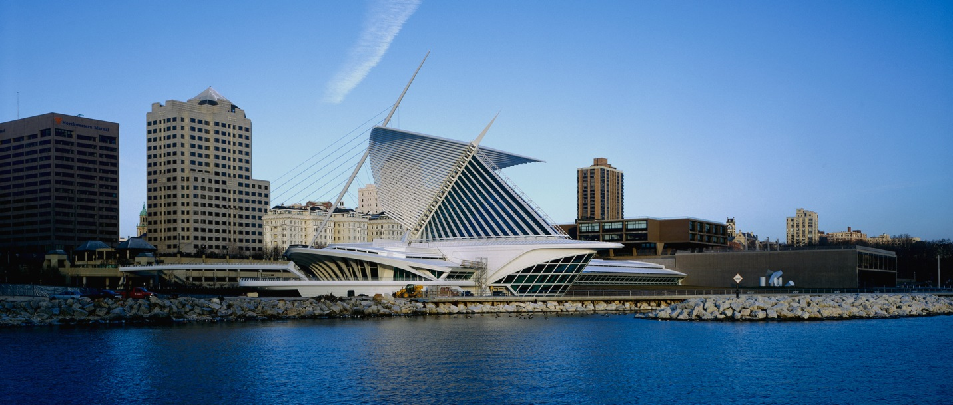
Contents
ABOUT HART & SWE 2
SCHEDULE 2
PROGRAM DETAILS 4
REGISTRATION 6
ACCOMMODATIONS 6
TRANSPORTATION 6
FAMILY FUN 11
CONTACTS 11
SPONSORS 11

ABOUT HART & SWE
The Heartland Annual Round Table was established to provide region H senators the opportunity to fully discuss the important upcoming SWE legislative and strategic business with their constituents; to provide region council members a chance to network and share best practices with others in the region; and to provide leaders throughout the region with the necessary leadership and operations training to make their SWE organizations run smoothly and effectively support SWE’s mission.

The Society of Women Engineers (SWE) is the world’s largest advocate and catalyst for change for women in engineering and technology. To ensure SWE members reach their full potential as engineers and leaders, the Society offers unique opportunities to network, provides professional development and shapes public policy. SWE champions the value of diversity. We inspire young girls to become engineers and support them with scholarships in order to expand the engineering profession’s ability to improve the quality of life for billions of people worldwide.
For more information about the Society please visit www.swe.org or call (312) 596-5223.

The organization is divided into regions to assist in communication flow from the Society to its members and vice versa. Region H (the Heartland Region) is the largest region with over 5000 members and it includes Wisconsin, Minnesota, Illinois, Indiana, Iowa, Michigan, North Dakota, and South Dakota. For more information about Region H, visit our website http://regionh.swe.org/, our blog http://regionh.wordpress.com/, or contact the region governor at governor-h@swe.org.

What to bring
Yourself, your ideas, your questions, your pen.

Bring details to share about successful programs you have run, bring lessons learned about events that have not gone as expected, and bring questions from others in your section or members at large. If you have any bright new ideas for improvement or programs, bring those as well.

Bring business cards so while you network and discuss SWE programs you can easily follow up later to get more information or clarification.

If you prefer a laptop to record notes and look up information that is fine too.

SCHEDULE

Friday, September 25, 2015
Time | Agenda Topic/Event Description | Contact
6:00 -7:00  Optional  RSVP required | Dinner with the Governor:  Rustico |223 N Water St. | Milwaukee, WI 53202  A couple blocks from next event.  www.rusticopizzeria.com  Meet there or in hotel lobby at 5:30 to carpool. | Betty Leonhard
7:30 -10:30 PM  Optional  RSVP required | Evening Networking Activity:  Splash Studio | 184 N. Broadway | Milwaukee, WI 53202  Registration Required: Online registration & payment through our website using a combination of SurveyMonkey & PayPal. | Julia Spankowski  jrspankowski@gmail.com  Angela Cowan

Saturday, September 26, 2015
Location of all sessions except lunch and dinner are at the Fairfield Inn
Time | Agenda Topic/Event Description | Presenter(s)
Before 8:50 AM | Breakfast is available in the hotel lobby | NA
8:00-8:45 AM  Optional | Nuts and Bolts of SWE & Region H  For those who have been SWE leaders for less than 3 years.  - SWE structure  - SWE online resources and website navigation  - Region reports  - Meetings and parliamentary procedure | Betty Leonhard
8:45-9:00 AM | Check In to HART outside the meeting room | Inga Bentley
9:00-9:25 AM | Welcome Round Table Ice Breaker | Julia Spankowski
9:25-10:30  SWE BUSINESS | Society  - Update from BOD | SWE BOD Member  (C.L. or TBD)
 | Region  - Lt. Governor Report  - Treasurer Report  - Rep to the Society Nominating Committee Report  - Outreach Liaison Report  - Region Awards Committee Report  - Celebrate SWE! at WE15  - Region Mentor Program Chair  - FY17 HART | Carol Weber  Gina Janke  Jennifer Morikawa  Jill Steffek  Amy Jones  Stephanie Foege
10:30-11:00 AM | Round Table Discussions on Best Practices
11:00-11:10 AM | Break
11:10-Noon  PROFESSIONAL DEVELOPMENT | Effective Personal Communications | SWE Leadership Coaching Committee
11:10-Noon  Concurrent | RCT Meeting with SWE Future Leaders  Breakout session in hotel lobby | Carol Weber & RCT
Noon: -2:00 PM  LUNCH & TEAM BUILDING | Lunch and Team Building  at Grand Avenue Mall  Location: 275 W Wisconsin Ave, Milwaukee, WI 53203  Walk across the street | Julia Spankowski
2:00-2:30 PM | Fund Development | Enanga Fale
2:30-3:15 PM  PROFESSIONAL  DEVELOPMENT | CREATIVITY INC. | Craig Ogurek  Froedtert Hospital
3:15-3:30 PM | Break / Snack
3:30-4:30 PM  SWE BUSINESS | Senate motions  Governance changes proposed to BOD, Senate, Region, Committees | Senators: Dayna Johnson, Jennifer Brooks, Abigail Hedlin
4:30-5:00 PM | Wrap up | Betty Leonhard
5:00-5:30 PM | Break
5:30-6:00 PM | Meet in lobby to carpool or walk to evening networking.

Saturday Evening, September 26, 2015
Time | Agenda Topic/Event Description | Contact
6:00-8:00 PM  Optional  RSVP required | TBD | Julia Spankowski

Attention SWE Business Presenters!
Please arrange slide presentations with Betty Leonhard (betty.leonhard@swe.org) prior to Wednesday, September 23 to allow for an efficient use of everyone’s time at HART.

PROGRAM DETAILS

Splash Studio
Friday evening networking with the SWE-Wisconsin section

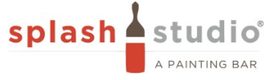http://www.splashmilwaukee.com

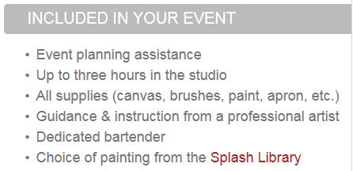
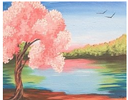
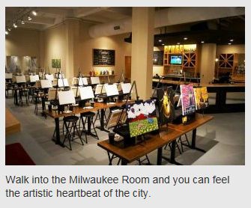
Splash Studio® is a painting bar. Come on in, grab a drink, and sit down in front of a canvas -- simple as that. At its core, Splash offers a three-hour experience with a local artist. That artist will guide you through an original painting, show you tips and tricks, and encourage you to take painting risks you never thought you had the skill to take. You can follow along with our (trendy, cool, hip) artists on staff who will be there to guide the stick-figured-challenged, or you can change up colors and techniques to make it your own. You'll walk out with a painting you love, and we'll take care of the cleanup.
The best part about Splash is that it was created with Milwaukee in mind. Its location in the heart of the Historic Third Ward arts and cultural district makes it great for date night, girls/guys night out, a private party, or just a "check me out of reality" evening. Its interior feels like a studio loft mixed with a trendy downtown bar, so you always know you're in Milwaukee when you are here. Most importantly, it was created for, and is dedicated to, Milwaukee's own emerging artists. Staff members are local painters, illustrators, photographers, and graphic designers who are bursting with creative energy. Their paintings hang throughout, and the Splash Gallery features their own original collections.

Distance from hotel: 1 mile
Cost: $35.00
Required: Registration, max of 55 people.

FY16 Society/ Senate/ Region Business
In FY16 SWE members will be encouraged to reach out to reach up. The Society is reaching out to international members and employers to understand their needs, to the small business and entrepreneur community via the senate strategic work, to potential new organization SWE might partner with, to our members by providing tools for local advocacy action, to pre-college girls signing up for the blossoming SWEnext membership, to academia and industry to find opportunities, and to SWE leaders to move to a more competency based governance structure with more value added volunteer activity. All of these efforts will help SWE reach up to meet our next phase as a Society, ushered in by our new logo.

Here in Region H, we will focus on using our SWE mentor program to reach out to reach up. Building strong SWE leaders help us fulfil our main purpose as a region: enabling our sections and members at large to be successful in everything they do at a grass roots level to meet all of SWE’s objectives. We’ll receive reports from region elected leaders and committee chairs that will keep us on track and provide us tools and knowledge to bring back to our members.

And to live up to the purpose of this meeting we will engage in some round table discussions and best practice sharing throughout the day.

Leadership Coaching session: Effective Personal Communications
Since 93% of communication is non verbal and people usually only recall 50% of what they just heard, we all need to be the best communicators we can be. This module discusses and practices the difference between ineffective and effective communication skills. It provides resources on all aspects of communication from interpersonal, to body language, to electronic messaging.

Lunch and Team Building at Grand Avenue Mall
The Shops of Grand Avenue is an urban shopping plaza that spans three city blocks in the downtown neighborhood of Westown in Milwaukee, Wisconsin. It opened in 1982 and hosted over 80 specialty stores, along with the largest food court in Wisconsin.

Distance from hotel: 433 Ft.

SWE will provide each HART registrant with a $10 stipend to go towards lunch.

Lunch options in the food court are:

- Applebee’s
- Cajun Gourmet Grill
- Culvers
- Jake’s Deli
- La Delicatesse
- Panda Express
- Peddler Jim’s Produce
- Potbelly Sandwich Shop
- Qdoba Mexican Grill
- Rocky Rococo
- Stone Creek Coffee Lounge
- Subway
- Tomato Destination
- Wild Flour Bakery

Teambuilding Scavenger Hunt: Meet in front of Applebee’s at 1:00 pm.

Creativity Inc- Craig Ogurek

Session:

We will look at focusing on the journey of accomplishing goals, and learning to adapt to an ever-changing marketplace. Creativity Inc is a book for managers who want to lead employees to new heights, a manual for anyone who strives for originality, and a trip into the tactics and knowledge used to develop some of the most successful, creative films in history. It is, at heart, a book about how to build a creative culture and empower employees to find solutions to problems. We will discuss how to seek new ideas, and ensure they are given a fighting chance. We will understand why people and ideas fail, and how to allow ourselves to broaden our opportunities. This presentation will focus on creativity, an expression of the ideas that make the best in us possible.

Biography:

As the Ambulatory Services Coordinator at Froedtert Hospital, Craig leads various projects and processes throughout the health care system. His efforts focus on team collaboration and standardization of clinic practices. The breadth of his project management ranges from competency development, to patient safety measures. Craig has worked in healthcare throughout his professional career, as a medical technician, registered nurse, and now health care administrator. He has served in a variety of settings, including the large institutions of Froedtert and Johns Hopkins, and a small assisted-living facility in Northern Wisconsin. Craig completed his Bachelor’s in Nursing at Marquette University, and his Master’s in Nursing and Health Systems Management at Johns Hopkins University. He plays an active role in leadership development at Froedtert, and takes pride in identifying unique solutions to patient and staff concerns. Craig holds a significant amount of passion for inspirational leadership techniques, and is always enthusiastic to share them. He currently resides in Wauwatosa, WI with his wife Maura.

Evening networking/dinner

Note that the original venue will be closed in September to relocate and was no longer available to book. We will update this document once the Saturday Evening program is confirmed.

REGISTRATION

RSVP IS REQUIRED FOR ALL MAIN EVENTS:
Friday Networking, Saturday HART meeting, & Saturday Dinner

All RSVP’s should be completed via https://www.surveymonkey.com/r/HART2015MKE

ACCOMMODATIONS
Rooms are reserved under Society of Women Engineers at:

Fairfield Inn & Suites
Downtown Milwaukee, 710 N. Old World Third Street
Website: http://www.marriott.com/hotels/travel/mkefd-fairfield-inn-and-suites-milwaukee-downtown/
Phone: 414-224-8400
Room Block Price: $119/ night + tax
- King or Double
- WIFI included
Airport: (MKE) General Mitchell Int’l, direct flights from MSP, ORD, IND, DTT
Transportation from Airport:~$30 Go Riteway (roundtrip)~$25 Taxi (one way)
13 min from airport
Parking: Valet parking, fee: 23 USD daily
Off-site parking, fee: 15 USD daily
Parking based on availability & not operated by hotel. Additional parking available in public garage across street.

TRANSPORTATION

The following pages provide maps and directions from the hotel to the dinners and other activities.
Friday: From Hotel to Splash Studio
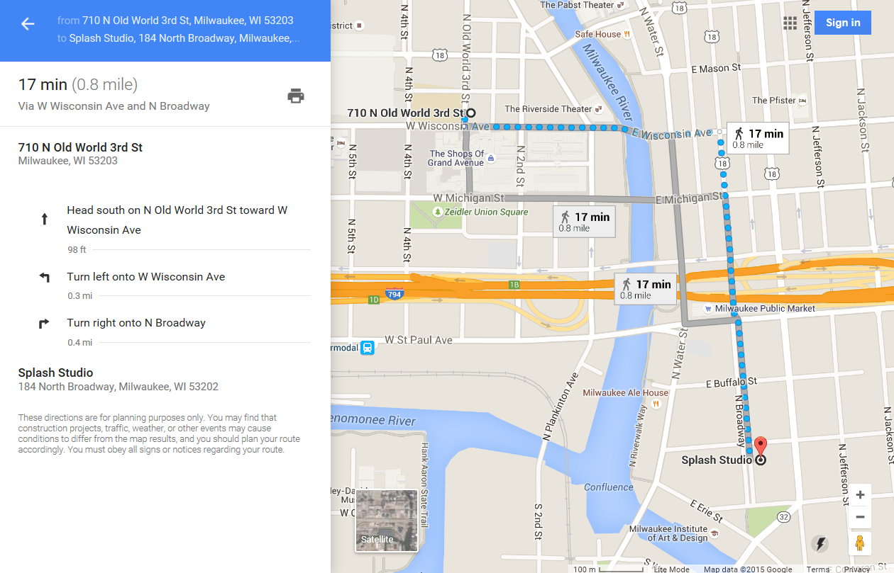

Saturday: From Hotel to Grand Avenue Mall
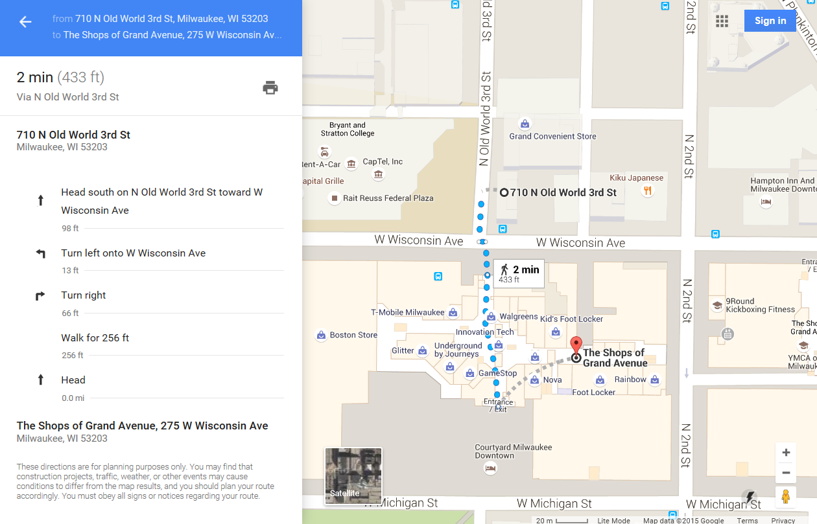

Saturday: From Hotel to Saturday Evening Program

FAMILY FUN
There’s much to do in Milwaukee! For more information, please check out: http://www.visitmilwaukee.org/
Milwaukee Bucket List
With so much to see and do, it's hard to narrow down the options for a great day out. Here are a few suggestions.
DISCOVERY WORLD
It’s maritime heritage meets 21st century cool at Discovery World. Explore interactive science and industry exhibits and pet the sharks in the Aquarium. Play guitar along with a virtual Les Paul, lie on a bed of nails and take a virtual walk through the universe.
MILWAUKEE ART MUSEUM
Designed by star international architect Santiago Calatrava, this striking architectural beauty features a “wing-like” sunscreen with a span equaling that of a Boeing 747 that can be raised or lowered. Inside you’ll find an extensive collection of American and European works, German Expressionist, decorative arts, folk art and a Haitian art collection. The museum is also home to one of the world’s largest Georgia O’Keeffe collections
MARCUS CENTER
Located along the RiverWalk, the Marcus Center for the Performing Arts is home to the Milwaukee Symphony Orchestra, Milwaukee Ballet, Florentine Opera, Milwaukee Youth Symphony Orchestra and renowned First Stage children’s theater. Touring Broadway and Off-Broadway shows also take the stage throughout the year.
Unleash your inner rebel at the Harley-Davidson Museum.
HARLEY-DAVIDSON MUSEUM
Unleash your inner rebel at the Harley-Davidson Museum. The museum chronicles the history of an American legend from the first Harley ever produced in 1903 through a priceless display of 450 bikes and also features Harley’s role in pop culture. Hop on one of the bikes at the end of the tour for a great photo op and stop at Motor Bar & Restaurant for Route-66-inspired foods.
MILWAUKEE PUBLIC MUSEUM
Stroll through the museum’s “Streets of Old Milwaukee” and be transported back to a time of gaslit walkways where you can peer into vintage shops and homes. Go on to explore a Costa Rican rainforest, a year-round live butterfly garden and see the world’s largest dinosaur skull.
MILWAUKEE COUNTY ZOO
Where better to take the family for an unforgettable visit than the nationally-recognized Milwaukee County Zoo? More than 2,500 animals, from bonobos to polar bears, and big cats to giraffes, are housed on 200 acres of natural habitats. Kids love the zoo train, and the new Sky Trail® Wisconsin Adventure Zone challenges all ages to try out the 500-foot zip line, climbing wall and ropes course.

CONTACTS

Julia Spankowski
HART Host Coordinator
SWE Wisconsin Section
jrspankowski@gmail.com
cell/text: 414-395-0344

Betty Leonhard
Region H Governor
governor-h@swe.org
cell 920-344-2344

Thank You for attending FY16 HART!

SPONSORS

Region H is grateful for all our donors throughout the year. Sponsors who wish to support HART may contact us via SWE_RegionH_Secretary@yahoo.com. By sponsoring HART they are supporting all our SWE members and the engineering profession through building stronger leaders for today and for the future of our profession. Sponsors will be noted on the SWE Region H website: http://regionh.swe.org/ and advertised at the event.

